Worksheet 1 - Signposting Language – Speaking Part 3

- Read some candidates’ answers to questions in part 3 of the Speaking test. What was the topic?
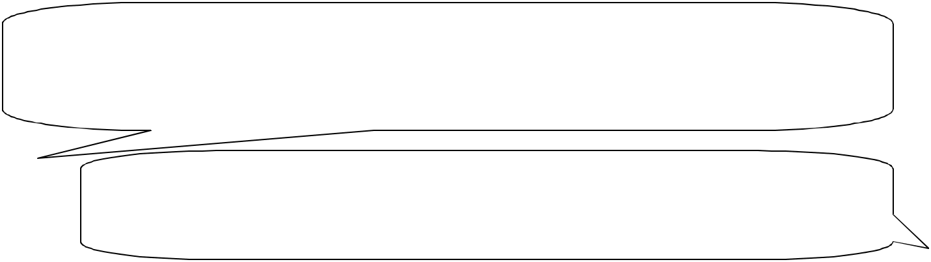

- No, I’m not sure I entirely agree with that because nowadays supermarkets tend to be located quite far away from residential areas. So if you haven’t got a car, I think it would be really difficult to do your food shopping. In the past, you could walk to a local shop in your village. These days most of them have closed down as a result of supermarkets taking their trade away…

- In my opinion, the main reason for the popularity of fast food is because it’s so convenient. We’re so readily tempted to a burger or a pizza because they’re very easy to get hold of. You also see ads everywhere for fast food. And it always looks delicious so you think…’Mmm…actually a burger would be nice’…


- Well, I suppose there are many differences, but I think the main one is that you tend to expect something more special…and probably less healthy, when you eat in a restaurant. Whereas when you eat at home, you’ve cooked it yourself so, unless you’re a chef, it’ll probably be less interesting, but not as unhealthy…

  - I really believe that in the future, we’ll eat very different types of food. Firstly, I think people will definitely stop eating genetically modified food – it’s got to be really bad for you. I doubt that people will just eat pills – eating is too pleasurable. If GM foods become less popular, I actually think that we might start to value healthy, tasty, natural food…

- Which person was asked to:

  - compare two things

  - comment on the past and present

  - speculate about the future

  - explain / give reasons for something

  - agree or disagree with a statement

- Underline the phrases which helped you answer the question above.

4. The speakers also used different phrases to introduce their opinion. Circle the phrases that they used (e.g. Speaker 1 = I think…)

5. For each answer, what do you think the question was?

Worksheet 2 - Signposting Language – Speaking Part 3

- Most people believe that shopping for food is easier today than it was in the past. What do you think?
- Why do you think that fast food is so popular these days?
- Can you tell me about the some of the differences between eating at home and eating in restaurants?
- How do you think our eating habits will change in the future?

Complete the table below with phrases from worksheet 1. Can you add any phrases of your own?


Language for | Language for |  | Language for | Language for | Language
comparing | talking about the |  | speculating about | explaining / giving | agreein
 | past |  | the future | reasons

Language for |  | Language
talking about the |  | disagree
present

Practice answering the questions with a partner. Don’t forget to use signposting language to help the listen

